TAILORING YOUR CV

This section will help you to tailor, or make small changes to, your general CV to the particular job which you are applying for. Employers looking to fill a job may read through a lot of CVs – so tailoring yours will really help to make your CV stand out.

There are several steps involved in tailoring your CV:

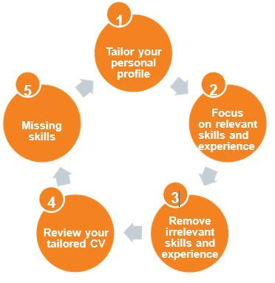

1) Tailor your personal profile

Your personal profile is the first impression an employer will form of you. Write it to match the job you are applying for by highlighting any relevant skills and experience.

2) Focus on relevant skills and experience

Go through your CV and pick out the experiences and skills that match what the employer is looking for. Add detail, so that they really show the employer that you are the kind of candidate they are looking for.

3) Remove irrelevant skills and experience

The employer might only take a few seconds to read through the CVs they receive, especially if there are a lot of them! Therefore it might be a good idea, if you have a long CV, to remove those parts which are not really relevant for the job that you are applying for.

4) Review your tailored CV

Using the job description, check that your CV is what the employer is looking for. Do the skills and experiences you have shown match with what the 'ideal candidate' might have?

5) Missing skills

If there are any areas of the job description which you haven't been able to show you are suitable for (e.g. if the job requires Microsoft Excel skills which you do not have), there are a number of things you can do:

- Show that you are trying to develop these skills (in the example above, you might do a Microsoft Excel course)
- Demonstrate that you are a fast learner
- Highlight skills related to the missing skill, which again might illustrate your ability to learn quickly (e.g. in this example, general IT skills).

Tip:
There is no need to include your date of birth or a photo.

